**Docker Task -2**

Create a Dockerfile, docker-compose file which, when executed, must display your basic details in the website.

**Create an App for Basic Details**

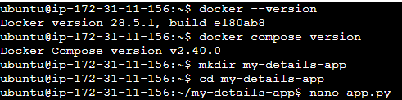

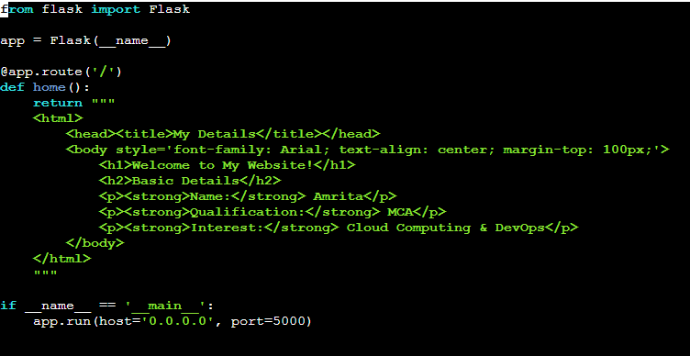

**Create a dockerfile**

nano Dockerfile

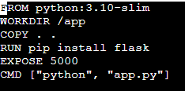

**Create a Docker Compose**

nano docker-compose.yml

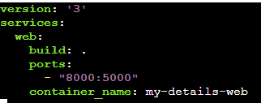

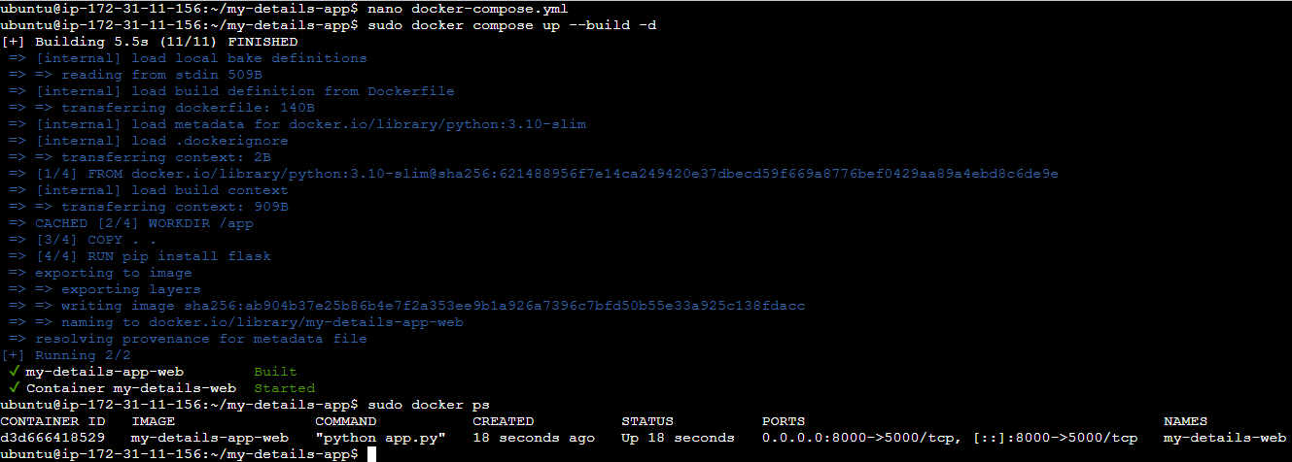

**Basic details on the website**

